Hands on 4
Difference between JPA, Hibernate and Spring Data JPA
1. What is Java Persistence API (JPA)?
The Java Persistence API (JPA) is a specification for managing relational data in Java applications. It provides a standardized way to persist, read, and manage data between Java objects and relational database tables using ORM (Object-Relational Mapping) techniques.
- It is part of the Java EE standard (JSR 338).
- JPA itself does not provide an implementation, it only defines interfaces and annotations like @Entity, @Id, @OneToMany, etc.
- A JPA provider like Hibernate or EclipseLink is required to use JPA in practice.

2. What is Hibernate Framework?
Hibernate is an open-source ORM (Object Relational Mapping) framework for Java. It provides a reference implementation of the JPA specification, making it one of the most popular JPA providers.
- Maps Java classes to database tables.
- Handles database communication and transaction management.
- Provides advanced features like caching, lazy loading, dirty checking, etc.
Note: JPA is a specification and Hibernate is an implementation of that specification.
3. What is Spring Data JPA?
Spring Data JPA is a part of the larger Spring Data family. It is a powerful framework that builds on top of JPA and Hibernate to make data access easier and faster.
- Not a JPA provider.
- Provides an abstraction layer that removes boilerplate code for DAO layers.
- Uses interfaces like JpaRepository, allowing developers to focus more on business logic.
- Supports derived query methods using naming conventions.
- Handles transactions declaratively with @Transactional.
Aspect | JPA | Hibernate | Spring Data JPA
Type | Specification/API | Framework/Implementation | Framework/Abstraction
Implementation | No | Yes (JPA Provider) | No (Works with JPA Providers like Hibernate)
Responsibility | Defines ORM rules | Implements ORM | Simplifies and abstracts JPA implementation
Transaction Handling | Not directly handled | Manually handled | Declaratively handled via @Transactional
Boilerplate Code | Moderate | High | Very Low
Usage | Annotations & Entity Management | Session, Criteria, Manual Transaction | JpaRepository, Custom Queries by Method Naming
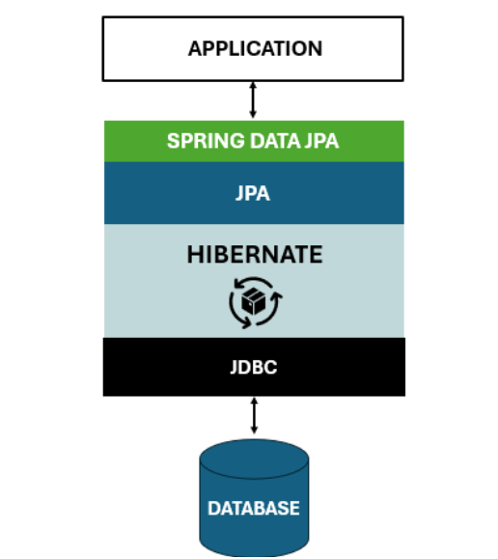

Code Comparison:
- Hibernate Approach (Manual Implementation)
public Integer addEmployee(Employee employee) {
Session session = factory.openSession();
Transaction tx = null;
Integer employeeID = null;

try {
tx = session.beginTransaction();
employeeID = (Integer) session.save(employee);
tx.commit();
} catch (HibernateException e) {
if (tx != null) tx.rollback();
e.printStackTrace();
} finally {
session.close();
}
return employeeID;
}
- Spring Data JPA Approach (Clean & Simple)
Repository Interface
public interface EmployeeRepository extends JpaRepository<Employee, Integer> {
}

Service Class
@Service
public class EmployeeService {

@Autowired
private EmployeeRepository employeeRepository;

@Transactional
public void addEmployee(Employee employee) {
employeeRepository.save(employee);
}
}
Conclusion
- JPA is the blueprint/specification for ORM in Java.
- Hibernate is a popular JPA implementation and full-fledged ORM framework.
- Spring Data JPA is a powerful abstraction built on JPA that makes CRUD operations simpler and cleaner.

